**Ideation Phase**

**HEMATOVISION - blood cell classifications**

|  |  |
| --- | --- |
| Date | 28 june 2025 |
| Team ID | LTVIP2025TMID59640 |
| Project Name | Hematovision |
| Maximum Marks | 4 Marks |

**Hematovision & Idea Prioritization Template:**

HematoVision aims to develop an accurate and efficient model for classifying blood cells by employing transfer learning techniques. Utilizing a dataset of 12,000 annotated blood cell images, categorized into distinct classes such as eosinophils, lymphocytes, monocytes, and neutrophils, the project leverages pre-trained convolutional neural networks (CNNs) to expedite training and improve classification accuracy. Transfer learning allows the model to benefit from pre-existing knowledge of image features, significantly enhancing its performance and reducing computational costs. This approach provides a reliable and scalable tool for pathologists and healthcare professionals, ensuring precise and efficient blood cell classification.

**Step-1: Team Gathering, Collaboration and Select the Problem Statement**

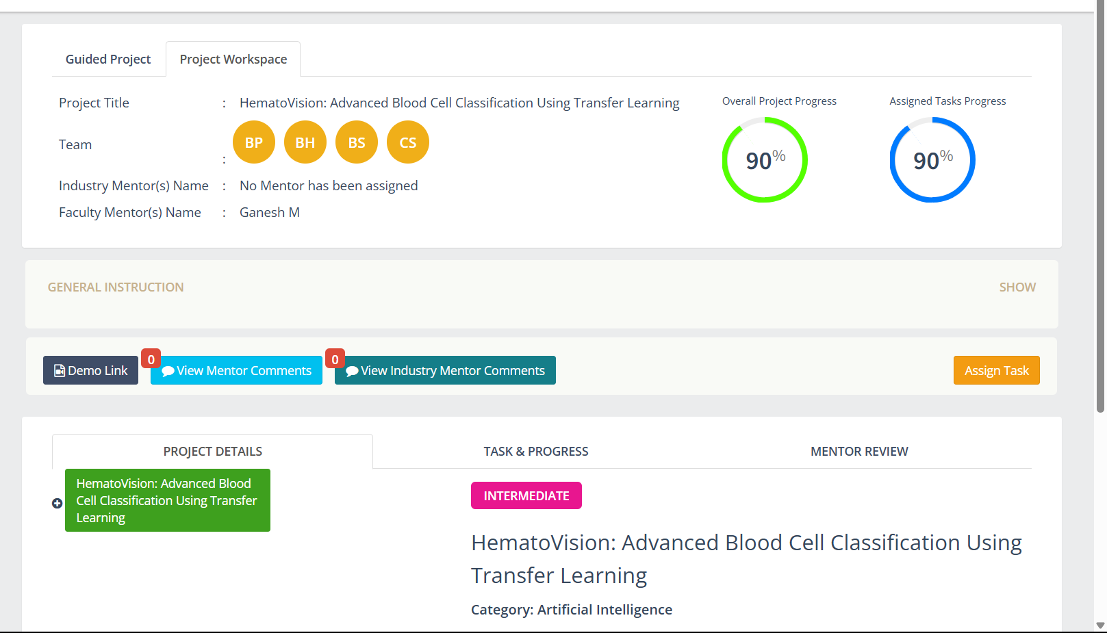

**Step-2: Hematovision, Idea Listing and Grouping**

**Step-3: Idea Prioritization**

